**............TubeInsight……….**

**……………………………………………….**

**A**

**Minor Project Report**

**Submitted in the partial fulfillment of the requirement for the award of Bachelor of Technology**

**In**

**Computer Science Engineering**

**Submitted to**



**Samrat Ashok Technological Institute, Vidisha**

(A Govt. Aided UGC Autonomous Institute Affiliated to RGPV, Bhopal)

Submitted by

**PANKAJ KUMAR PANDIT** (0108CS211090)

**SHRIKANT KURMI** (0108CS211122)

**UDIT RAJPUT** (0108CS211129)

**VAIBHAV WANODE** (0108CS211131)

Under the supervision of

**Prof. Satish Pawar**

Assistant Professor

Department of Computer Science and Information Technology Samrat Ashok Technological Institute Vidisha (M.P.) – 464001

**April 2024**



**SAMRAT ASHOK TECHNOLOGICAL INSTITUTE, VIDISHA**

(A Govt. Aided UGC Autonomous Institute Affiliated to RGPV, Bhopal)

**CERTIFICATE**

This is to certify that the Minor Project entitled as **“TubeInsight”** submitted by Pankaj Kumar Pandit(0108CS211090), Shriknat Kurmi(0108CS211122), Udit Rajput(0108CS211129), Vaibhav Wanode(0108CS211131)**,** in the partial fulfillment of the requirements for the award of degree of **Bachelor of Technology** in the **Computer Science Engineering** from **Samrat Ashok Technological Institute, Vidisha (M.P.)** is a record work carried out by him under my supervision and guidance. The matter presented in this report has not been presented by him elsewhere for any other degree or diploma.

**Prof. Satish Pawar** **Prof. Divya Rishi Sahu** **Dr. Kanak Saxena**

(Project Guide) (Project Coordinator) (Head of Department) Computer Science and IT Computer Science and IT Computer Science and IT

Samrat Ashok Technological Institute Samrat Ashok Technological Institute Samrat Ashok Technological Institute

Vidisha M.P. Vidisha M.P. Vidisha M.P.



**SAMRAT ASHOK TECHNOLOGICAL INSTITUTE, VIDISHA**

(A Govt. Aided UGC Autonomous Institute Affiliated to RGPV, Bhopal)

**CANDIDATES’S DECLARATION**

“I, hereby declare that the work which is being presented in the Minor Project entitled **“TubeInsight”** submitted in partial fulfillment of the requirement for the award of the degree of **Bachelor of Technology** in **Computer Science Engineering.** The work has been carried at **Samrat Ashok Technological Institute, Vidisha** is an authentic record of my own work carried out under the guidance of **Prof. Satish Pawar** (Assistant Professor, Department of Computer Science & Information Technology), **Samrat Ashok Technological Institute, Vidisha (M.P).**

The matter embodied in this report has not been submitted by me for the award of any other degree or diploma.

Date:

Place: **Vidisha, (M.P)**

Pankaj Kumar Pandit (0108CS211090)

Shriknat Kurmi (0108CS211122)

Udit Rajput (0108CS211129)

Vaibhav Wanode (0108CS211131)

**III Year, Computer Science Engineering**



**SAMRAT ASHOK TECHNOLOGICAL INSTITUTE, VIDISHA**

(A Govt. Aided UGC Autonomous Institute Affiliated to RGPV, Bhopal)

**ACKNOWLEGDMENT**

The full semester project has proved to be pivotal to my career. I am thankful to my institute, **Samrat Ashok Technological Institute, Vidisha** to allow me to continue my disciplinary/interdisciplinary project as a curriculum requirement, under the provisions of the Flexible Curriculum Scheme (based on the AICTE Model Curriculum 2018), approved by the Academic Council of the institute. I extend my gratitude to the Director of the institute, **Dr. Y. K. Jain** and Dean Academics, **Dr. Jitentdra Parashar** for this.

I would sincerely like to thank my department, **Computer Science Engineering,** for allowing me to explore this project. I humbly thank **Dr. Divya Rishi Sahu**, Coordinator, Computer Science Engineering, for his continued support during the course of this engagement, which eased the process and formalities involved.

I am sincerely thankful to my faculty mentors. I am grateful to the guidance of **Prof. Satish Pawar, Assistant Professor, Computer Science Engineering**, for his continued support and guidance throughout the project. I am also very thankful to the faculty and staff of the department.

Pankaj Kumar Pandit (0108CS211090)

Shriknat Kurmi (0108CS211122)

Udit Rajput (0108CS211129)

Vaibhav Wanode (0108CS211131)

**III Year, Computer Science Engineering**

**ABSTRACT**

In the digital era, online platforms like YouTube host an immense volume of user-generated content, with comments playing a crucial role in audience engagement. The YouTube Comment Analyzer model presented in this project aims to leverage machine learning to extract valuable insights from the vast comment sections of YouTube videos.

This model employs natural language processing (NLP) techniques to analyze sentiments, identify key topics, and evaluate the overall sentiment polarity of comments. it categorizes comments into positive, negative, or neutral sentiments, providing content creators with a deeper understanding of audience reactions.

We looked at when comments were made to see if people talk more right after a video is uploaded. We also made a picture of the most used words to know what people talk about the most. Another tool helped us know if comments were positive, negative, or neutral.

Our findings showed that people engage differently over time, especially in the first few days after a video goes live. We also learned what topics or feelings show up the most in comments. This could help people who make videos better understand what their viewers like or don't like. But, we should remember that these tools might not catch everything, so it's still important to think about what people say carefully.

In short, this project helps us understand what people say about YouTube videos. It could help video creators and others make better decisions about what content to create, keeping viewers' interests in mind.

**Keyword:**

YouTube Comment Analysis

Sentiment Analysis

User Engagement Insights

YouTube Comment Feedback

Comment Sentiment Classifier

Sentiment Polarity Analyzer

YouTube Analytics Model

YouTube Data API v3

**TABLE OF CONTENTS**

**TITLE PAGE NO.**

**Abstract IV**

**List of figures 1**

**CHAPTER 1: INTRODUCTION 2**

1.1 Project Aim

1.2 Objective

**CHAPTER 2: SYSTEM SPECIFICATION 3**

2.1 Hardware Specification

2.2 Software Specification

**CHAPTER 3: METHODOLOGY 4**

3.1 Data Collection

3.2 Data Pre-processing

3.3 Data Visualisation

3.4 Server Building

3.5 Model used

3.6 User interface

3.7 Application

3.8 Problem

3.9 Limitation

**CHAPTER 4: TECHNIQUES AND TOOLS** 14

4.1 Technologies used

4.2 Tools used

**CHAPTER 5: CONCLUSION** 18

**References 18**

**LIST OF FIGURES**

**Figure Number Figure caption Page No.**

3.1 Data Set 4

3.2 Data Preprocessing 5

3.3.1 Barchart 6

3.3.2 Line Chart 7

3.3.3 Word Cloud 7

3.4 App 8

3.5 Model 9

3.6.1 HTML 10

3.6.2 CSS 10

3.6.3 Java Script 11

3.6.4 Final UI 11

3.6.5 Final UI 12

**Chapter 1: Introduction**

Our project, the YouTube Comment Analyzer, is like a clever friend for Creators. We are creating a smart tool that looks at what people say in the comments. We want to understand if they're feeling happy, sad, or just okay and discover what topics they like talking about the most. It's like having a helpful friend who guides video creators on what their viewers like. Our big goal is to make YouTube a more positive and enjoyable place for everyone. By understanding people's feelings and interests, we hope to bring more smiles and good vibes to the world of YouTube, making it a happier space for all of us!

* 1. **Project Aim**

Our project aims to improve the YouTube experience for everyone by creating a clever tool. This tool will look at the comments people leave on videos to understand if they feel happy, sad, or just okay. We want to know what topics they enjoy talking about the most. It's like having a friendly helper for video creators, guiding them on what viewers like. Our goal is to use this information to make YouTube a more positive and enjoyable community. By understanding what makes people happy, we hope to bring smiles and good vibes to the world of YouTube and make it a better place for everyone.

* 1. **Objective**

Our project's main objective is to create a super-smart tool for Creator. We want this tool to understand how people feel when they leave comments on videos, whether they're happy, sad, or just okay. The goal is to figure out what topics people like talking about the most. With this information, our aim is to help video creators make even better videos that everyone enjoys. We also want to assist moderators in keeping the online community a friendly and positive place. Our objective is to use smart technology to bring more joy, understanding, and good vibes to YouTube for everyone who watches and creates content.

**CHAPTER 2: SYSTEM SPECIFICATION**

**2.1 Hardware Specification**

Since the hardware is an important part while developing a web project, it's necessary to find

hardware requirements.

Processor–

The minimum level of the required processor for this platform is Pentium IV with 800 MHz

processing speed.

Since the time taken for processing the instruction depends on the processor’s power, it is very

important to choose the required processor

RAM–

For a higher speed of processing, it also depends on the memory. Therefore, for better performance

minimum RAM should be 2 GB.

Hard disk–

In modern days, a vast amount of data is generated daily from internet platforms. So, a good size

hard disk is required for the storage of the processed data.

Cache Memory–

The access time of the operation tasks mainly depends on the cache memory. Therefore, the

recommended cache memory is 1000 KB

**2.2 Software Specification**

Our system should meet the following minimum specifications

OS — Ubuntu, Windows, Mac OS

We will be using HTML, CSS, JAVASCRIPT, and Python and we also need an application Visual

Studio Code and PyCharm as a code editor.

**CHAPTER 3: METHODOLOGY**

**3.1 Data Collection:**

For this project, data collection was done with the help of API provided by YouTube (YouTube Data API v3). The API provides access to YouTube's vast repository of videos, channels, playlists, and comments, enabling the retrieval of valuable information necessary for analyzing user comments on the platform.

* **Data Acquisition Process**
* **API Key Generation:** Access to the YouTube Data API v3 necessitated the generation of an API key through the Google Developers Console. This unique key served as the authentication mechanism for making requests to the API endpoints.
* **Endpoint Queries:** The API endpoints were utilized to retrieve information about videos, including their titles, descriptions, upload dates, view counts, and most importantly, the comments posted by users. Requests were made to obtain comment threads associated with selected videos based on search criteria and video identifiers.
* **Data Filtering and Storage:** Upon receiving the API responses, the data underwent preliminary filtering to exclude irrelevant or duplicate comments. The collected data, including comment text, user details, timestamps, and engagement metrics, was stored in a structured format for further analysis.

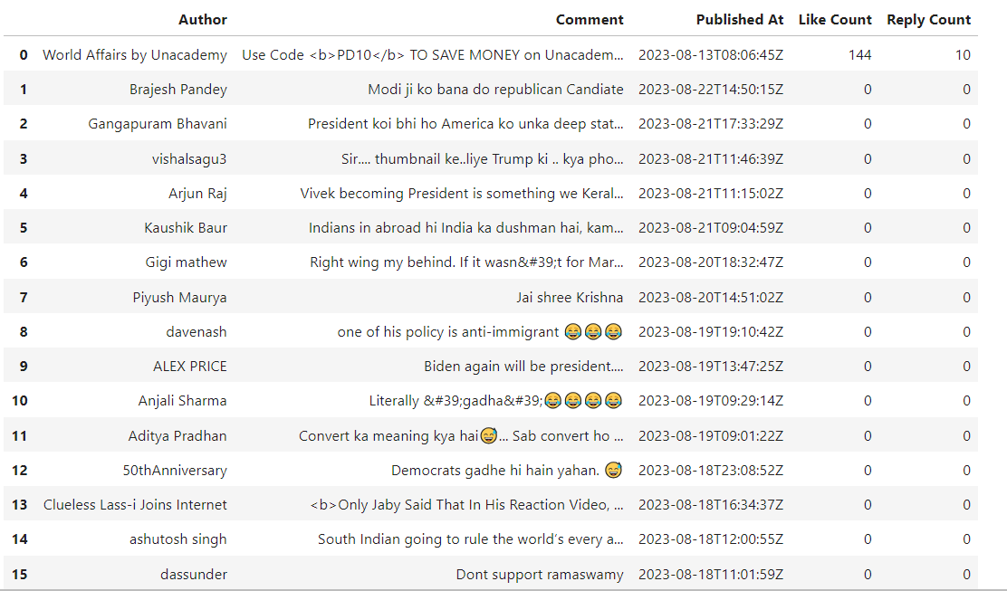

**Figure 3.1**

**3.2 Data Pre-processing:**The obtained data from the YouTube Data API v3 arrived in a formatted structure, containing relevant attributes such as comment text, user details, timestamps, and etc. As a part of the preprocessing pipeline, language translation to English was implemented to ensure uniformity and enhance the accuracy of subsequent analysis and modelling tasks.

Azure Translation Services were directly employed to translate all comments, regardless of their original language, into English. Azure Translation for Language Standardization: Leveraging Azure's translation capabilities, all comments, irrespective of their original language, were translated into English using the available APIs.

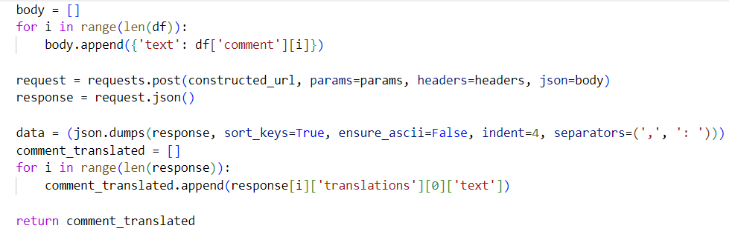

**Figure 3.2**

**3.3 Data Visualisation:**

Visualization plays a pivotal role in comprehending patterns, trends, and insights within datasets. In this YouTube comment analysis project, visual representations were generated to elucidate temporal trends and the linguistic landscape of comments through graphical plots and word cloud representations.

**3.3.1 Overall Comments Over Time**

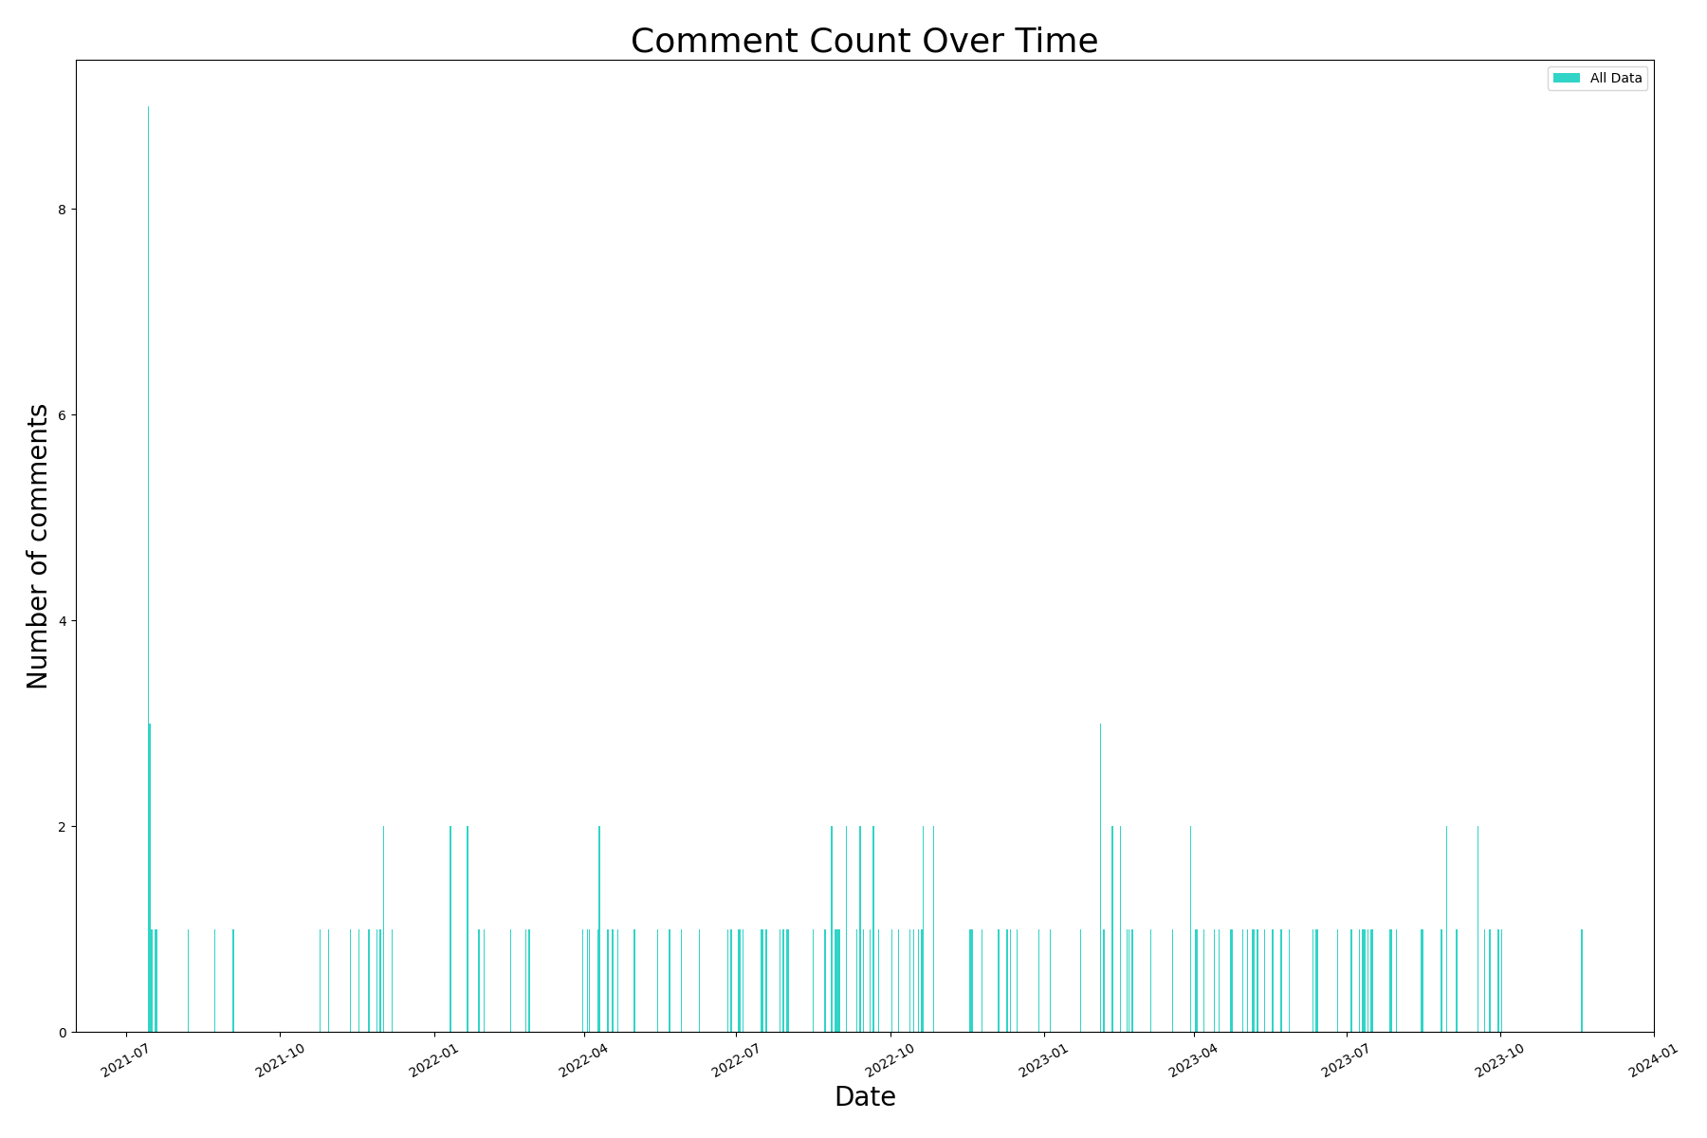

**Figure 3.3.1**

The first visualization illustrates the distribution of comments over time, encompassing the entire dataset duration. The x-axis represents time, segmented into relevant intervals (daily, weekly, or monthly), while the y-axis denotes the count of comments posted during those intervals. This graph provides an overview of the comment influx and potential spikes or trends observed across the entire period.

**3.3.2 First 7 Days' Comments Over Time**

The second visualization specifically focuses on comments within the initial seven days following video upload. Similar to the first graph, this visualization showcases the comment frequency but specifically emphasizes the comments' pattern and engagement within the crucial early period after video publication. It helps identify trends in user engagement shortly after the video's release.

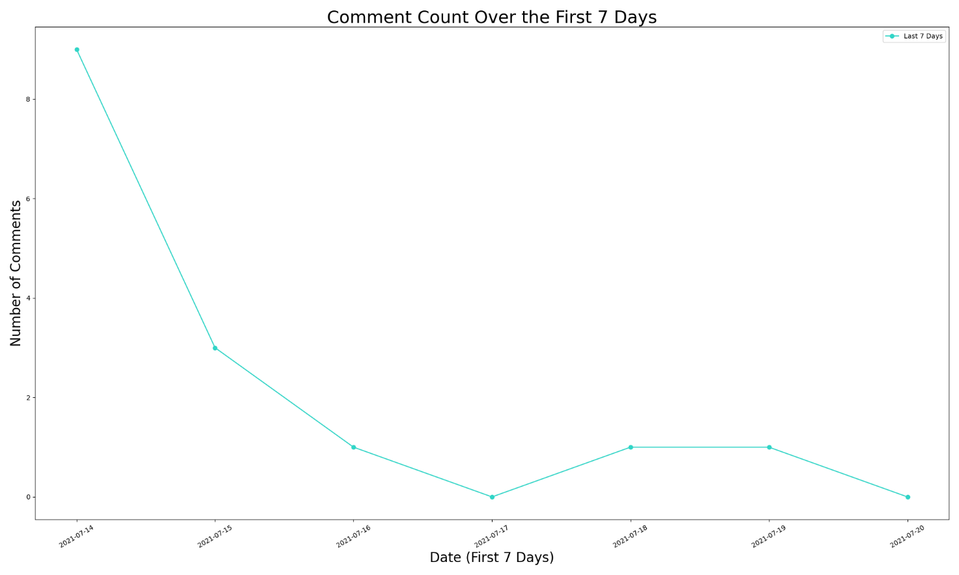

**Figure 3.3.2**

**3.3.3 Word Cloud Representation**

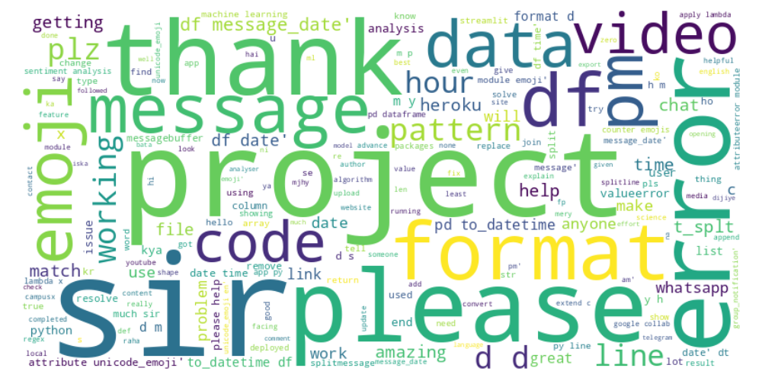

**Figure 3.3.3**

a word cloud representation was generated based on the comments collected. The word cloud visually emphasizes frequently occurring words in the comment corpus. Word size corresponds to the frequency of appearance in the comments, providing a quick visual snapshot of the most common topics or sentiments expressed by viewers.

**3.4 Server Building:**

Flask is a popular web framework that can be used to build a server for a machine-learning model. Flask is a lightweight and flexible framework that allows you to quickly create web applications in Python. Flask provides a simple way to handle HTTP requests and responses, making it easy to integrate with machine learning models.

**app.py**

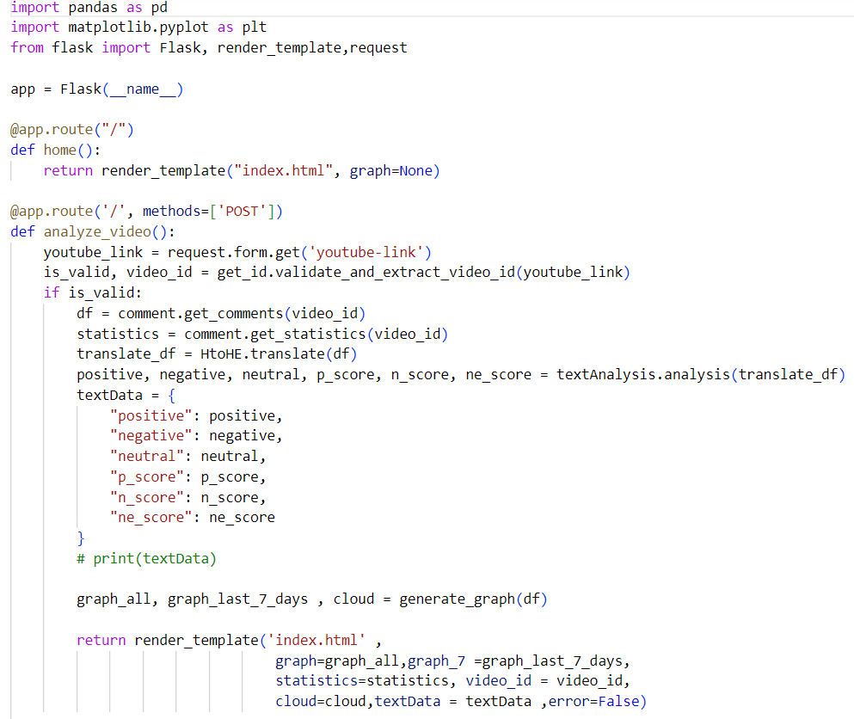

**Figure 3.4**

**3.5 Model Used: Azure Text Analytics for Comment Analysis**

For the analysis of comments gathered from YouTube using the YouTube Data API v3, an AI-based model from Azure Text Analytics was utilized. Azure Text Analytics provides a suite of natural language processing tools that enable sentiment analysis, key phrase extraction, language detection, and other text analytics functionalities, which were instrumental in deriving insights from the comment dataset.

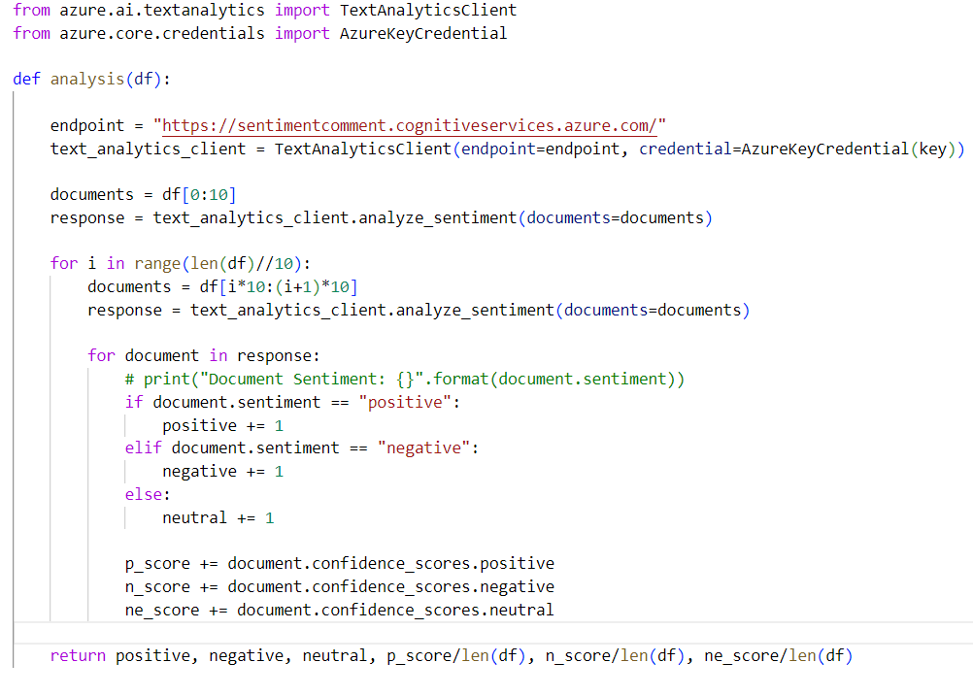

**Figure 3.5**

**3.6 User Interface:**

HTML, CSS, and JavaScript can be used to build a user interface for a machine-learning model. HTML provides the structure of the page, CSS provides the styling and layout, and JavaScript provides the interactivity.

**HTML:**

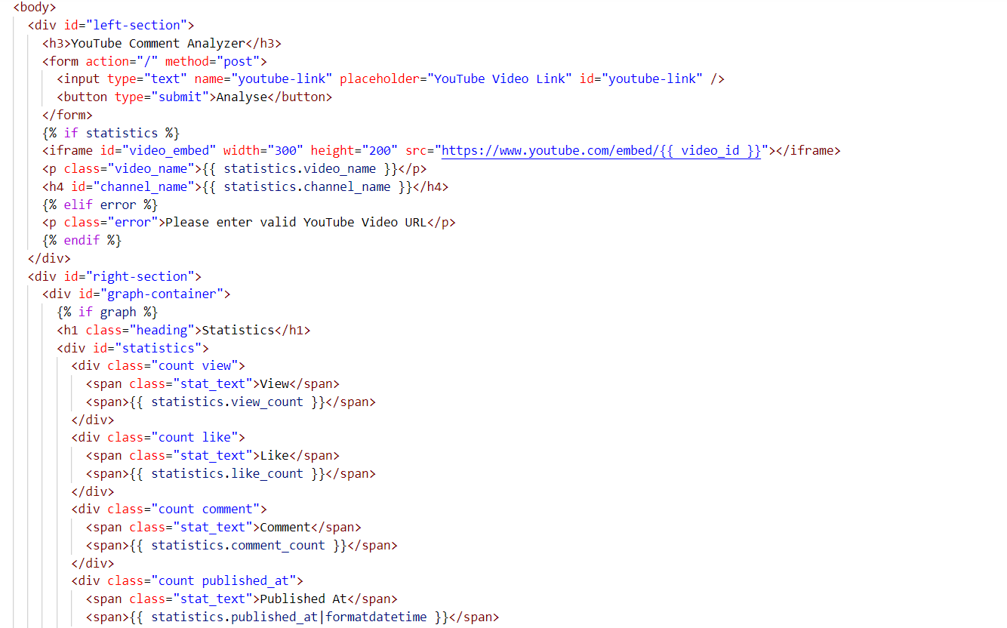

**3.6.1**

**CSS:**

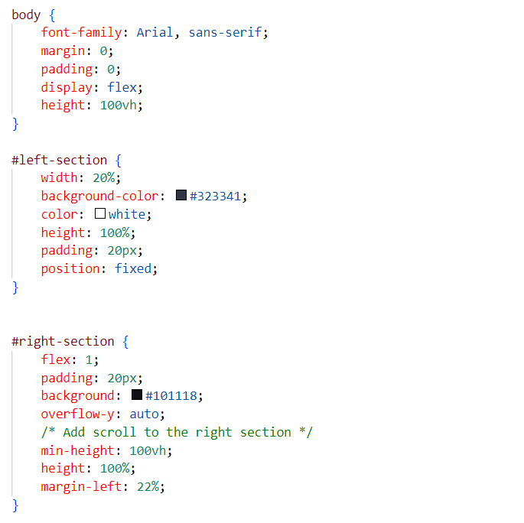

**Figure 3.6.2**

**JavaScript:**

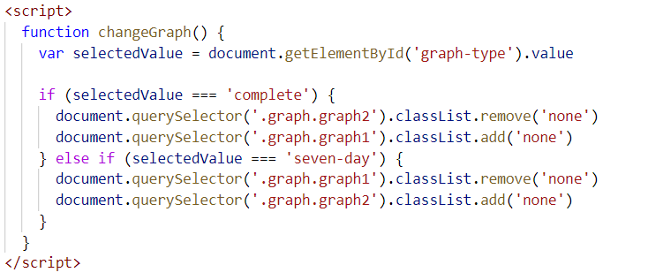

**Figure 3.6.3**

**Final UI:**

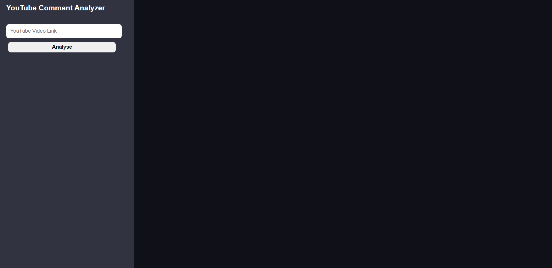

**Figure 3.6.4**

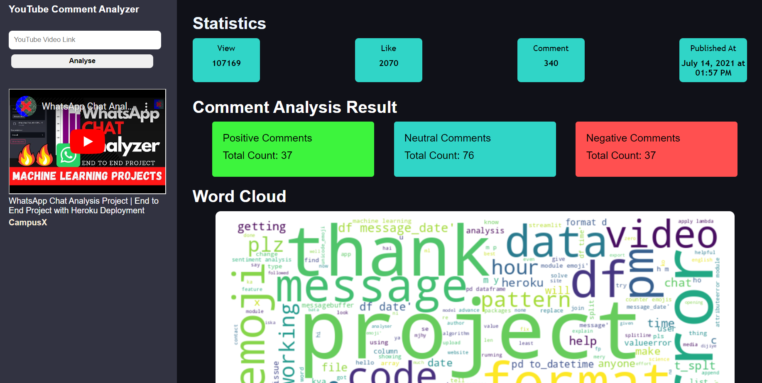

**Figure 3.65**

**3.7 Application of the YouTube Comment Analyzer Model:**

* Content Optimization
* Community Engagement
* Feedback Analysis
* Trend Identification
* User Experience Enhancement

**3.8 Problems Faced during Model Development**

* **Manage Data Quantity**

The huge volume of comments available for analysis give a significant challenge due to resource limitations, including computational power, storage capacity, and processing time. Analyzing a massive number of comments could overwhelm available resources and hinder timely analysis and model development**.**

Limiting the scope of comment analysis to a specific subset or a set number of comments becomes a pragmatic strategy. By strategically sampling or setting a cap on the number of comments analyzed, the project can focus on a representative subset rather than attempting to process the entire vast volume.

**3.9 Limitations of the YouTube Comment Analyzer Model**

* **API Limitations and Financial Constraints:**

One limitation encountered during the project was the restriction imposed by the usage limits of the free access tier of the API service. As the project progressed, the free tier's limitations, including the restricted number of API requests or access to premium features, hindered the ability to scale or access advanced functionalities. Due to budget constraints, upgrading to a paid API subscription for expanded access or higher usage limits became unfeasible for the project's scope or financial resources. This constraint affected the frequency of data retrieval, analysis capabilities, and access to enhanced features, ultimately impacting the depth and breadth of insights derived from the YouTube comment dataset.

* **Handling Large-Scale Data:**

The time required for processing extensive volumes of data posed a significant limitation during the project. Analysing the substantial dataset obtained from YouTube comments using various natural language processing (NLP) techniques demanded considerable computational resources and time.

As the dataset size increased, the processing time grew significantly, impacting tasks such as sentiment analysis, language translation, and key phrase extraction. The scalability of the computational infrastructure became a limiting factor in handling larger datasets effectively within reasonable time frames.

**CHAPTER 5: TECHNIQUES AND TOOLS**

Technologies and tools refer to the various software, hardware, and other resources that are used to

accomplish a specific task or achieve a particular goal. They are often used interchangeably, but

generally, technologies refer to the broader range of resources and methods used to achieve a specific

outcome, while tools refer to specific software applications, hardware devices, or other resources

used to carry out specific tasks.

**4.1 Technologies used**

* **Python**

Python is an interpreted, object-oriented, high-level programming language with dynamic semantics. Its high-level built-in data structures, combined with dynamic typing and dynamic binding, make it very attractive for Rapid Application Development, as well as for use as a scripting or glue language to connect existing components together. Python's simple, easy-to learn syntax emphasizes readability and therefore reduces the cost of program maintenance.

* **Libraries**
* **Pandas**

Panda is an open-source library designed primarily for working quickly and logically with relational or labeled data. It offers a range of data structures and procedures for working with time series and numerical data. The NumPy library serves as the foundation for this library. Pandas is quick and offers its users exceptional performance & productivity.

* **NumPy**

NumPy is the fundamental package for scientific computing in Python. It is a Python library that provides a multidimensional array object, various derived objects (such as masked arrays and matrices), and an assortment of routines for fast operations on arrays, including mathematical, logical, shape manipulation, sorting, selecting, I/O, discrete Fourier transforms, basic linear algebra, basic statistical operations, random simulation and much more.

* **Matplotlib**

Matplotlib is a widely used Python library for creating visualizations, including charts,

graphs, and plots. It provides a wide range of tools for data visualization, making it a

popular choice in the field of machine learning (ML). Matplotlib supports a wide range

of plots, including line plots, scatter plots, bar plots, histograms, and more.

* **Backend or Server**

Flask is a popular Python web framework that allows developers to build web applicationseasily and quickly. It is a lightweight and flexible framework that provides essential tools andfeatures for building web applications. Flask is based on the WSGI (Web Server GatewayInterface) standard and is compatible with most web servers and platforms.

Flask provides a range of features for web application development, including routing, templating, session management, and security. It also supports the use of extensions, which allows developers to add additional functionality to their web applications, such as database integration, authentication, and more.

* **API**
  + **YouTube Data API V3**

The YouTube Data API v3 is a powerful tool provided by YouTube to access and interact with their vast repository of video content. It allows developers to retrieve information such as video details, playlists, channels, and Comment. This API enables the integration of YouTube data into applications, websites.

* + **Azure Text Analytics**

Azure Text Analytics is a service provided by Microsoft Azure that leverages natural language processing (NLP) capabilities to extract valuable insights from unstructured text data. It is designed to analyze and understand the sentiment, key phrases, and language of text documents, making it a powerful tool for text-based data processing.

**Sentiment Analysis:** Azure Text Analytics can determine the sentiment expressed in a piece of text, classifying it as positive, negative, or neutral. This feature is useful for understanding the emotional tone of user reviews, social media posts, and other textual content.

* + **Azure Text Translation**

Azure Text Translation is a service provided by Microsoft Azure that facilitates language translation within applications, websites, and other solutions. This service leverages advanced machine learning and neural machine translation technologies to provide accurate and context-aware translations for various languages.

* **Frontend or User Interface**
* **HTML**

HTML (Hypertext Markup Language) is a markup language used for creating web pages and other information that can be displayed in a web browser. HTML is the backbone of the World Wide Web and is used to structure and display content such as text, images, and multimedia on websites.HTML consists of a series of elements that define the structure of a web page.

* **CSS**

CSS (Cascading Style Sheets) is a style sheet language used for describing the presentation of a document written in HTML (Hypertext Markup Language). CSS is used to define the visual appearance of a web page, including its layout, colours, fonts,

and other styling options.CSS works by separating the content of a web page from its presentation

* **JavaScript**

JavaScript (JS) is a programming language used to create dynamic and interactive web pages. It is widely used in web development for creating client-side scripts that run in web browsers, and server-side scripts that run on web servers. JavaScript is a high-level, object-oriented programming language that supports eventdriven, functional, and imperative programming styles.

**4.2 Tools used**

* **PyCharm**

PyCharm is an integrated development environment (IDE) used for Python programming. PyCharm provides a range of features designed to help developers write and debug Python code more efficiently. Some of its key features include code completion, code analysis, debugging, and version control integration. PyCharm also provides a range of tools for web development, including support for popular web frameworks such as Django and Flask

* **VS code**

Visual Studio Code, often abbreviated as VS Code, is a free, open-source code editor developed by Microsoft. It is designed for building and debugging modern web and cloud applications and supports a wide range of programming languages, including Python, JavaScript, and TypeScript. VS Code provides a range of features, including syntax highlighting, code completion, and debugging tools

**CHAPTER 5 : CONCLUSION**

In conclusion, our YouTube Comment Analyzer project has been a journey to make YouTube a friendlier and more enjoyable space. We've learned to understand people's feelings in the comments and discovered the hot topics they love to talk about. With this information, video creators can now make content that everyone loves. Our aim is to be a helpful tool, like a wise friend, guiding creators and keeping the YouTube community positive and happy.

As our project wraps up, it's not just about computers and data – it's about creating a place where everyone on YouTube feels good, smiles more, and enjoys the experience. The adventure to make YouTube even better doesn't stop here; it continues with the hope of spreading joy and good vibes throughout the platform.

Overall, our YouTube Comment Analyzer is like a helpful friend for YouTube. We've learned to understand if people are happy or not in the comments and discovered the favorite topics they like to talk about. This means video creators can now make better videos that everyone enjoys.

**References**

* <https://flask.palletsprojects.com/en/3.0.x/>
* <https://docs.python.org/3/>
* <https://matplotlib.org/stable/index.html>
* <https://developers.google.com/youtube/v3/docs>
* <https://learn.microsoft.com/en-us/python/api/azure-ai-textanalytics/?view=azure-python>
* <https://learn.microsoft.com/enus/python/api/azurecore/azure.core.credentials?view=azure-python>
* <https://learn.microsoft.com/en-us/azure/ai-services/translator/>
* <https://stackoverflow.com/>
* https://pypi.org/project/wordcloud/